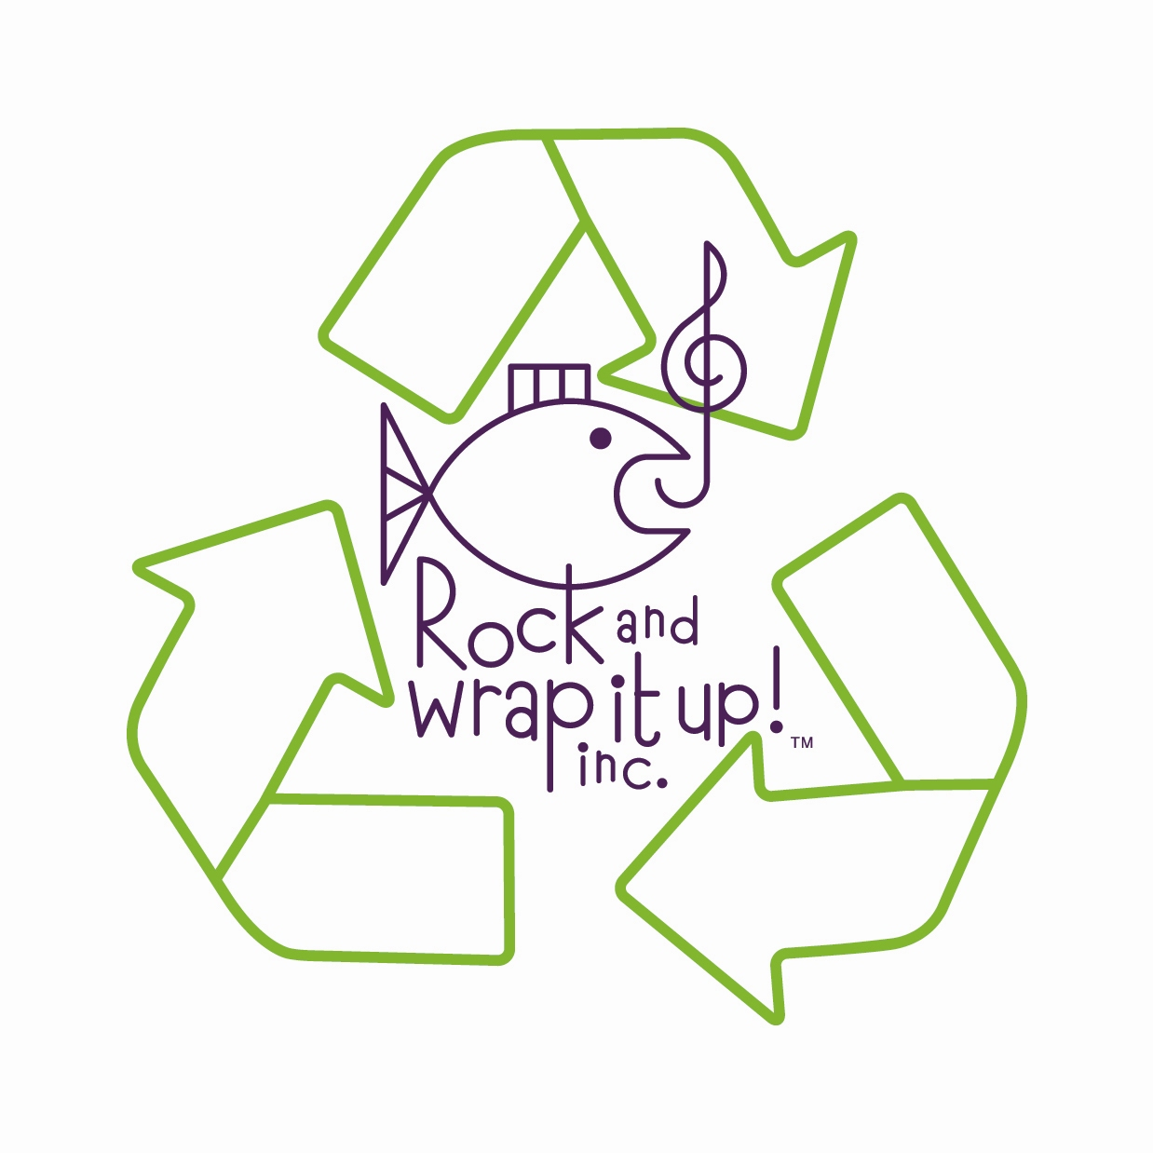
5 Year Case Study for Hotel Wrap!

According to the Food Research and Action Center, 2012 was the fifth year the Gallup organization asked hundreds of thousands of households the food/toiletries hardship question, “Have there been times in the past twelve months when you did not have enough money to buy food that you or your family needed?” 18.2 percent of all households answered “Yes” to this question. As of 2013, 49 million, or 16%, of Americans are food/toiletries insecure. One in four men between the ages of 25-34 earned poverty level wages in 2013.
In May, 2009 after meeting with Marriott Marquis Management including Mike Stengel, Diana Shapiro and Corlette James, we piloted our first Hotel Wrap! asset recovery program of toiletries generated from the New York Marriott Marquis. The recovery covered toilet paper, tissue boxes, shampoos and conditioners and other vanity items which had previously been discarded when guests checked out of their room. The Marquis, (1950 rooms), had allowed us to conduct a training and awareness workshop for the entire housekeeping staff covering the social and environmental impact of helping the poor and reducing waste to land fill. Representatives of Rock and Wrap It Up! partner agencies, who would be conducting the recovery efforts also addressed the house staff. Emphasis was placed on the fact that all collected items were staying in the New York area. We received great feedback and started the collection.

Analysis completed by the Whole Earth Calculator
Example: Bowery Mission
Social Impact
-Averages 450 pounds of toilet paper week, 23,400 pounds per year, 117,000 pounds over 5 years
-1/2 rolls weight average of 4 ounces, 4 rolls to one pound
-1800 half rolls are recovered. Cost @ $.45 saving Bowery Mission $405 per week or $21,000 per year.
Using the Hotel Wrap! model, since 2009, $105,000 has been saved and put to poverty-reducing actions ie, job training, tutors, psychologists, social workers instead of paying for toilet paper. The Bowery Mission also recovers shampoo and conditioner from the W and Thompson Hotels.

Environmental Impact
The estimate for the savings by using 117,000 pounds or 585 tons of toilet paper (instead of wasting it and replacing it with new paper) are 206.5 MTCO2E (Metric Tons CO2 Equivalent, using the EPA WARM calculator of -3.53).
Saving 585 tons of toilet paper for use instead of wasting, saves a net 206.5 MTCO2 compared to the alternatives of land-filling it, or burning it.

Conclusions:
The program was declared a success by the hotel and supported agencies alike. Expansion of this program soon took place with the Eastside Marriott, LaGuardia Marriott, Uniondale Marriott and both Ritz Carletons. Our partnerships have grown out of the New York area; LA, Boston and Las Vegas. We partnered with anti-poverty agencies, which are vetted by Rock and wrap it Up! who also participate in our Sports, School and Music Wrap! programs, recovering school-generated food.
There is no limit to the growth of Hotel Wrap! Millions who suffer the affliction of poverty will have greater agency support. Millions of tons of CO 2 will not be released into the atmosphere. There has never been a greater need to generate more assets to help hungry Americans from a brand new asset stream, Hotels.

About Rock and Wrap It Up!

Now entering its 24th year, Rock and Wrap it Up! (RWU) is an award-winning anti-poverty think tank. We research, discover and nurture potential donors who have renewable assets to share. Recognized by the White House with a Point of Light Award and receiving numerous EPA distinctions, we strive to re-earn these honors every day.
Asset donors include touring bands, educational institutions, the hospitality industry, professional sports teams, hospitals and TV/film productions throughout North America. We find and vet agencies that need these resources thereby reducing the poverty footprint while reducing the carbon footprint. All of our partners are protected by the Bill Emerson Good Samaritan Act (Pub. L. No 104-210, 110 Stat. 3011(1996) as long as safe food handling is used. Over one billion meals have been recovered since 1991.
RWU wrote and helped pass the Federal Food Donation Act of 2008 (Pul. L. 110-247 122 Stat. 2314(2008) The Act encourages federal buildings to donate food from their restaurants, cafeterias and from outside rentals to feed our nation’s hungry. We launched Hungerpedia.com in late July 2011. The Hungerpedia web destination is a North American compilation of anti-poverty/hunger agencies vetted by RWU to receive and recover asset donations.
Food waste accounted for 14.5% of municipal solid waste in 2012, according to the latest EPA figures. That's 36 million tons of food scraps and 96% of it was incinerated or thrown into landfills, where it decomposes and generates methane, a potent greenhouse gas. At the same time, 14.5% of U.S. households were deemed "food insecure," meaning they lacked access to enough food for an active, healthy life for all household members.. The USDA and the EPA issued The Food Waste Challenge in 2013 to feed people not landfills.
There is no cost to partner with Rock and Wrap It Up and the group has a crew of 5,000 volunteers in 500 cities that handle the food recovery. For more information, go to the Rock and Wrap It Up! website or call Rock and Wrap It Up at 877-691-FOOD. Our website has vetting forms under heading Hungerpedia.

Rock and Wrap it Up! Whole Earth Calculator Application

Rock and Wrap it Up! (RWU) was the first anti-poverty think tank to tie together food recovery and greenhouse gas emission reduction. Our mantra, reducing the poverty footprint by reducing the carbon footprint remains our goal.
Currently our partners/sectors in asset and food recovery include music, sports, tv/film production, hospitals, hotels and schools. They are supplied with statistics including pounds recovered with meal equivalents and greenhouse gas emission reduction through embedded spreadsheets. Food that is prepared but not served or sold is recovered and given to the indigent across the US and Canada. The data which is supplied by Rock and Wrap It Up! is currently put on websites and reported to management.
The RWU Whole Earth Calculator is a mobile phone/tablet application which converts pounds of food donated to the poor into total meals and CO2 reduction statistics. The Hotel Wrap! version also calculates the impact of paper and plastics. The Whole Earth Calculator is not a downloadable tool but a non-native, web-based app.
The statistical data can be reported in English or metric units. The application supports social media handshakes. i.e., tweets on Twitter and posts on Facebook. More importantly, data collected is captured virtually and recorded on RWU donor spreadsheets for statistical analysis and marketing purposes. RWU has partnered with the United States Departments of Agriculture and Environmental Protection Agency, participating in their Food Waste Challenge Programs. The RWU Whole Earth Calculator application will further increase the inclusion in the Food Waste Challenge of food donor participants across the country.
The Rock and Wrap It Up! School Program will be expanded by the utilization of the application. Both science and economic curricula is being developed to accompany these applications for use in the school community. Students will be sensitized to keeping food waste out of land fill and new tactics to feed the poor. The application will increase food recovery and promote further positive environmental outcomes.
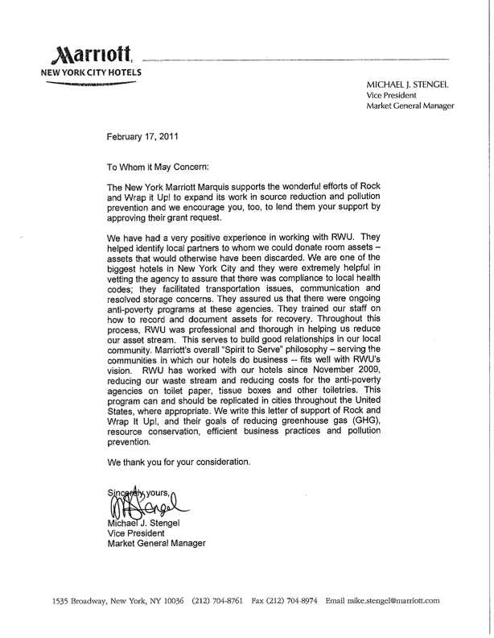

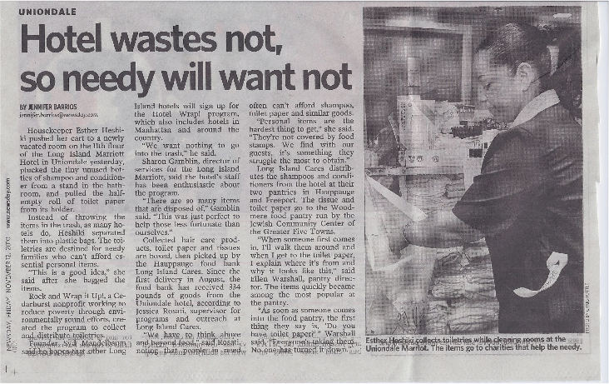


Nonprofit Matches Hotels, Agencies in Charitable Venture That Reduces Waste
By Glenn Hasek 12/13/2011
One way to reduce costs related to waste removal while keeping waste out of the local landfill is to give away items to those in need. In the lodging industry “waste” can include food, toiletries, partially used rolls of toilet paper, or even guestroom furnishings. Finding the right agency to donate items to can be a challenge. To save time and labor, it has got to be an organization willing to pick up the items. It has also got to be an organization that can be trusted—one that will actually deliver the items to those in need. What is the best way to find that agency?
While attending the recent International Hotel/Motel & Restaurant Show in New York City, I had an opportunity to meet Syd Mandelbaum, founder and CEO of Rock and Wrap It Up! Their organization specializes in matching up hotels with agencies experienced in delivering food and other used items to those in need—not only during the holiday season but year-round. I strongly recommend checking out Rock and Wrap It Up! Their program for hotels is called “Hotel Wrap!”
After many years of working with rock bands, sports teams, schools and the U.S. government, Rock and Wrap It Up! began working with hotels two years ago. Mandelbaum received a call from the secretary of a San Francisco-based lawyer who had stayed at the Grand Hyatt New York in New York City. The lawyer was concerned about what happened to the partially used amenity items at the hotel. A representative from the Grand Hyatt then contacted Rock and Wrap It Up! which then put the hotel in touch with Grand Central Homeless Services. Now the Grand Hyatt donates its half-used toilet paper rolls and toiletries.
California Hotels Participate
“We started branching out to other hotels,” Mandelbaum says. Another hotel that began working with Rock and Wrap It Up! was the Langham, Huntington Hotel & Spa in Pasadena, Calif. The hotel’s leftover food and unused toiletries are now donated to Union Station Homeless Services, a social service agency in the San Gabriel Valley that assists homeless and low-income individuals. Other hotels in California are also working with Rock and Wrap It Up!
“Our recent success was at the Marriott Marquis [in New York City],” Mandelbaum said. “We spoke to 150 housekeepers and 40 housemen and staff at a daily morning meeting. “We got them inspired to join the project. We showed them who would be receiving the unfinished rolls of toilet paper and amenities. We learned from some of the housemen that some guests purchase larger containers of shampoo and soap and leave them at the hotel. These items are sometimes almost full. These types of items account for about 20 percent of what we are getting.”
Mandelbaum emphasized that his organization’s goal is to make the donation process seamless for the hotel. He realizes that hotels do not have the space to store food or partially used toiletries, toilet paper or tissue boxes. From his many years of experience working with agencies throughout the United States, he knows which ones can be relied on to pick up donations.
Experience with Logistics
“We are masters at the logistical end of this,” Mandelbaum said. “We know that the people are actually going to show up and that the agencies will use the items.”
Thall said Hotel Wrap! is a win-win for hotels for a number of reasons. The volume of waste sent to the landfill is reduced, waste removal costs are trimmed, and the program is a morale booster for staff. “Housekeepers and other staff feel good about what they are doing,” she says.
Rock and Wrap It Up! has a small staff and an annual budget of just approximately $400,000 but thousands of volunteers provide the help that is needed. To learn more about Rock and Wrap It Up! and Hotel Wrap!, go to www.rockandwrapitup.org call (877) 691-3663, e-mail sydmandelbaum@att.net, Follow on Facebook and Twitter @rockywrap

